
Parish of
All Saints, Stretford

Sunday 16th April 2017
Easter Day

This week’s hymns are on a separate sheet

Readings for today – Easter Day
Acts 10.34-43 Billy Tomkinson
Gospel: Matthew 28.1-10
Intercessions: Valerie Smith
Lay Assistants: Billy Tomkinson Albert Martyn
Sides People: Margaret Croft Florence Wass

TO REMEMBER IN OUR PRAYERS THIS WEEK

We give thanks for those who have had prayers answered and pray especially for the sick and distressed including: Baby William, Marie Cook, Emma Mitchell, Barry Rook, Roy Roach, Andrea O’Brien, Phil Wall, Chris Cook, Rita Southern, Alma Pratt, Rose Partington, Joan Welch, Tracey Cook, Karen, Allan Roberts, Chris Allen, Joan Hornby, Simon Pitt and Stephen Tomkinson.

We remember all the recent faithful departed and we remember all who mourn for their loved ones.

We also remember those whose names appear in our Book of Remembrance, including: Jason Box, Ann Peel, Rose Hampson and Dorothy Williamson

May they each rest in peace and rise again in glory. Amen


Matthew 28.1-10

28After the Sabbath, as the first day of the week was dawning, Mary Magdalene and the other Mary went to see the tomb. ²And suddenly there was a great earthquake; for an angel of the Lord, descending from heaven, came and rolled back the stone and sat on it. ³His appearance was like lightning, and his clothing white as snow. ⁴For fear of him the guards shook and became like dead men. ⁵But the angel said to the women, ‘Do not be afraid; I know that you are looking for Jesus who was crucified. ⁶He is not here; for he has been raised, as he said. Come, see the place where he* lay. ⁷Then go quickly and tell his disciples, “He has been raised from the dead,* and indeed he is going ahead of you to Galilee; there you will see him.” This is my message for you.’ ⁸So they left the tomb quickly with fear and great joy, and ran to tell his disciples. ⁹Suddenly Jesus met them and said, ‘Greetings!’ And they came to him, took hold of his feet, and worshipped him. ¹⁰Then Jesus said to them, ‘Do not be afraid; go and tell my brothers to go to Galilee; there they will see me.’

Readings for next week – 23rd April, 2nd Sunday of Easter
Acts 2.14a,22-32 Dorinda Blackley
Psalm 16 Stuart Gilbertson
1 Peter 1.3-9 Albert Martyn
Gospel: John 20.19-31
Intercessions: Beryl Davies
Lay Assistants: Valerie Smith Margaret Dawson
Sides People: Mandy Tomkinson Christine Davies

Next week’s services to which everyone is welcome to attend;
Mon-Thurs: Morning Prayer 8am
Monday: Silent Prayer 2pm
Tues: Ecumenical Prayer 9.45am
Wednesday: Mid-Week Eucharist 9.45am

Annual Easter Egg Raffle
£1 a strip – Last Chance!!
Prize drawn TODAY!!
See Margaret Croft for Tickets after the Service

CHURCH NOTICES

ANNUAL PARISH MEETING (APCM): Sunday 30th April 11.30am. Forms for nominating Church Wardens, PCC Members and Sides Persons are at the back of church. If you would like more information please speak to Luke.

WOMENS BREAKFAST: Saturday 22nd April8.30am at the Melville Pub

DMPC Meeting: For those who are on the DMPC the next meeting is Wednesday 3rd May 7.30pm at St Bride’s Old Trafford

Deanery Dementia Celebration Service: Sunday May 14th St Mary’s Davyhulme. Everyone is very welcome.

CHRISTIAN AID WEEK: starts week commencing 14th to 20th May 2017, envelopes will be available for those wanting to donate.

Archdeacon Visitation Service: There is a single Visitation for Manchester Archdeaconry this year: Wednesday 24 May at Manchester Cathedral 7.30pm

Deanery Ascension Day Service: 7pm Thursday May 25th St John’s Old Trafford, fireworks 9pm.

Sharing the love of Christ, the Light of the World, with the people of Stretford.
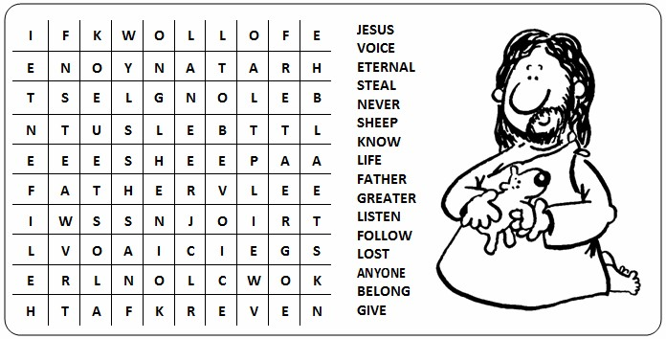
CHURCH CONTACTS
Priest in Charge: Revd. Luke Maguire 0161 865 1350
Churchwarden: Beryl Davies 0161 865 9380
PCC Secretary: Steve Worsley 0161 864 2069
E-mail: steveworsley65@gmail.com
PCC Treasurer: David Morris
E-mail: ascstretfordtreasurer@gmail.com

Weddings, Reading of Banns, Baptisms and other matters may be arranged by contacting the Churchwarden or Secretary above.

The church hall can be used as a meeting place or as a venue for your party? The hall is available for single events or regular meetings. Enquiries about booking the church-hall can be made by ringing the

Hall Booking Secretary Mon-Fri 9am-5pm (Muriel - 865 7171).
Find out all about us on our website
Look us up at www.allsaintsstretford.org.uk or on Facebook

Prayer for EASTER DAY


Lord God,
You loved this world so much,
That you gave your one and only Son,
That we might be called your children too.
Lord, help us to live in the gladness and grace of Easter Sunday, every day.
Let us have hearts of thankfulness for your sacrifice.
Let us have eyes that look upon your grace and rejoice in our salvation.
Help us to walk in that mighty grace and tell your good news to the world.
All for your glory do we pray, Lord.
Amen.

