Administrative Information
This report is offered by the Parochial Church Council (PCC) to the Annual Parochial Church Meeting as a record of its activities for the year of our Lord 2014.

All Saints

All Saints’ Church is situated in Barton Road, Stretford. It is part of the Diocese of Manchester within the Church of England.

Correspondence address: The Rectory
233 Barton Rd
Stretford
M32 9RB.

Priest in Charge: Revd. Luke Maguire (Since November 2015)

Insurers: Ecclesiastical

Independent Examiner: Mr David Homer
10 Manor Rd
Stretford
M32 9JT

Hall Bookings Secretary: Mrs Muriel Costello

Asst Wardens: June Kettle
Margaret Dawson

Website and Publicity

A website exists to provide information to the wider community. The website is updated at regular intervals, and to date has been visited by a large number of people. There have also been a number of contacts for hall bookings, replacement certificates and baptisms. We also have a Facebook page that has received 100s of views, this is more to publicise events as they happen.

Parochial Church Council

The members of the Parochial Church Council (PCC), who are the trustees of the charity, present their annual report and financial statements for the year ended 31 December 2015.

Members of the PCC are either ex officio (as office holders) or elected at the Annual Parochial Church Meeting (APCM). Meetings are normally held on a Wednesday evening and we have around 8 meetings per year, there may be additional meetings during the year to cater for any extra volume of business.

During the year, the following have been members of the PCC;
Chair: Revd. Luke Maguire

Secretary: Steve Worsley*

Treasurer: Anthony Slack* (David Morris Treasurer Elect Nov 2015)

Warden: Beryl Davies*

Diocesan Synod Duncan Gilbertson
Representatives: Steve Worsley

Deanery Synod Beryl Davies
Representatives: Steve Worsley

Elected Members: Margaret Croft (Until the APCM)
William Tomkinson (Until the APCM)
Dorothy Nuttall (Until June 2015)
Stuart Gilbertson
Duncan Gilbertson
Valerie Smith
Mandy Tomkinson
Eva Clague
June Kettle
Bea Morrow
Carl Horne
Julie Butler

Ex officio members of the PCC are denoted by an asterisk (*).

Structure, Governance and Management

The method of appointment of PCC members is set out in the Church Representation rules.
All Church attendees are encouraged to register on the Electoral Roll and stand for election to the PCC.

Objectives and Activities

All Saints’ PCC has the responsibility of co-operating with the Priest in Charge, in promoting in the ecclesiastical parish the whole mission of the Church, pastoral, evangelistic, social and ecumenical matters.

This responsibility embraces the current Diocesan Vision and Mission:

Vision: Run the Race…….Look to Jesus
Mission: Growing congregations, increasing giving, serving the community and nurturing vocations

It also has the maintenance responsibilities of the Church/Hall of All Saints’, Barton Rd, Stretford.

Reports

Church Worship and Attendance

All Saints continued to have services for major festivals and special events. In March we had an Ash Wednesday Service, the usual mid-week Holy Communions are held along with All Saints and All Souls Commemoration services. Some of our services were changed slightly to reflect the season e.g. Harvest Festival etc and at Christmas we had a Carol Service and Crib and Crafts service for younger members..

Sunday Worship:
10am – average 30 attendees (with up to 40 regulars) and several new attendees.

Wednesday Worship:
9.45am – 10 attendees (of which there will be 5-6 that would have attended a Sunday service as well)

Steve Worsley
PCC Secretary

Electoral Roll Officer Report
The following table provides an overview of the Electoral Roll numbers for 2015

Start of 2015 | 64
End of 2015 | 58

At the time of this APCM there are 61 members on the list.

Stuart Gilbertson
Electoral Roll Officer

Vicars Report

It is with a deep sense of thanksgiving that I am writing this report. First of all I would like to express my thanks to our good and generous God for all that he is doing in the life of our parish. Secondly, I would like to say a great big thank you to all who have, in some way, contributed to the life of our church. Finally, I would like to thank all who have done so much to keep our church going during the interregnum. I have taken charge of a church that is in good shape.

I arrived in the parish on 1st November 2015, the new Priest-in-Charge, and much has happened since then. On 2nd November we held a beautiful All Souls memorial service, to which we invited the families of those known to us who have been recently bereaved. My first Sunday in the parish was Remembrance Sunday with prayers at the war memorial. During Advent we enjoyed a visit from the Stretford Silver Band, held a successful Carols by Candlelight, and were delighted to have 19 children in Church on Christmas Eve for crafts and a crib service. Midnight Mass was also extremely well attended.

Links with our schools have continued, with my first assembly at Barton Clough Primary School in December and a pastoral visit to Moss Park Junior School in November. The Year 7s of Lostock College came to visit church in December and our affiliation agreement with that school is about to be renewed. There is much potential in our work with local schools and I look forward to building on the foundations that have already been laid.

As a parish we have experienced a flurry of baptisms and still have a good number in the pipeline. This is an encouraging sign that provides us with a greater opportunity to reach out to young families.

Over the coming year our focus as a parish will be to ‘dig in with God’. Before we can build upwards, we need to set deep foundations, and to this end our focus will initially be on revisiting the basics of our faith, strengthening our fellowship, and exploring once more the life-giving disciplines of prayer and bible study. Our aim is to become more attentive to the voice of God and to discern what his will is for our community.

Among the challenges we face are the need to build stronger links with the local community and to find creative ways of sharing the Good News of Jesus with our parish. Our attendance saw a slight increase towards the end of 2015, but we would love to see more growth (numerical and spiritual), increased diversity, and a lower age profile.

I look forward to the year ahead and to partnering with you in the service of Christ and his Gospel.

Reverend Luke Maguire
Priest-in-Charge

Financial Report

Total receipts for General (unrestricted) funds were approx. £35,400 and are detailed in the Financial Statements following this report. In addition, we benefited from a legacy of £1,000 which PCC agreed should be allocated to the ‘designated’ Fabric Fund established last year.
Hall income was down by over £2,000 on the previous year but rental income for the Lomond Avenue property is some £1,700 higher, reflecting occupancy for a full year. Receipts from regular giving are slightly down on the previous year but one-off Gift Aid donations continue to provide a valuable additional source of income.
The amount of Gift Aid recovered from the Inland Revenue is in respect of not only the regular/one-off contributions made under a Gift Aid declaration but also loose collections (subject to a cap of £5,000 – increasing to £8,000 for the 2016-17 tax year). Gift Aid reclaimed is applied towards the Parish Share, thereby reducing the amount paid from general income.
A total of £37,900 was spent to provide the Christian ministry from All Saints. This included meeting in full our contribution to the Diocesan Parish Share - which largely provides the stipends, pensions and housing for the clergy (the amount requested from each parish is determined by a formula based in the main on an annual income survey completed by congregational members, together with the average weekly attendance over a defined period).
The net result for the General Fund was a deficit of approx. £2,500 – thereby reducing the General Fund balance at the end of the year to just over £11,500, plus a further £7,000 in the ‘designated’ Fabric Fund.
The balance in the restricted Fabric Fund will be applied to ongoing repairs/renovations to the Church & Hall. The other restricted balance relates to monies collected/donated for specific charitable purposes but not yet distributed.
This is my final report as treasurer to All Saints PCC. I wish to record my thanks to all those who have undertaken some of the key financial activities - counting, recording and banking of weekly receipts, ensuring prompt payment of invoices, administering the Gift Aid schemes and managing hall bookings - during my time in office.
Anthony Slack
Hon PCC Treasurer

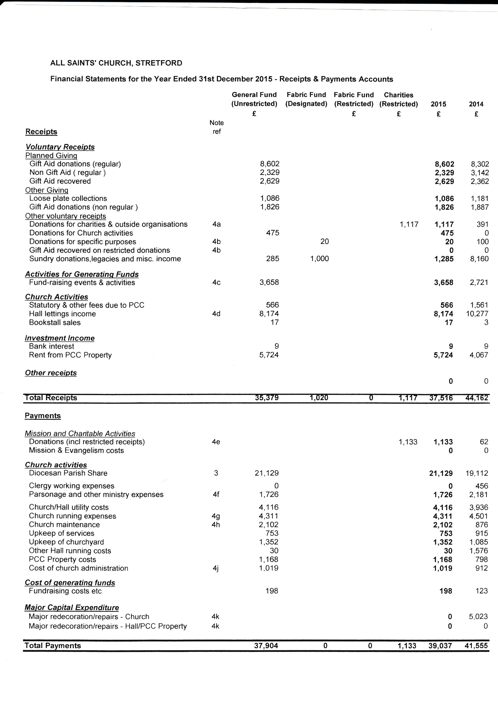

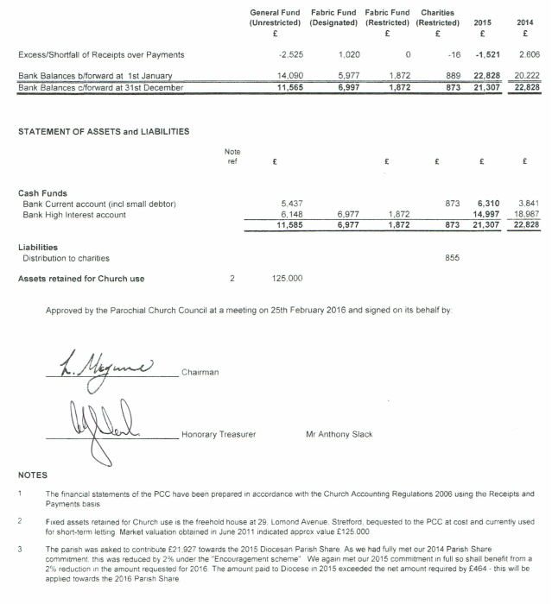

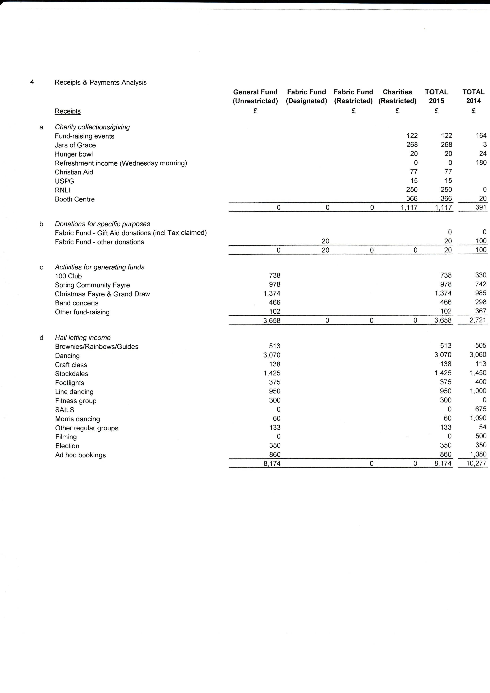
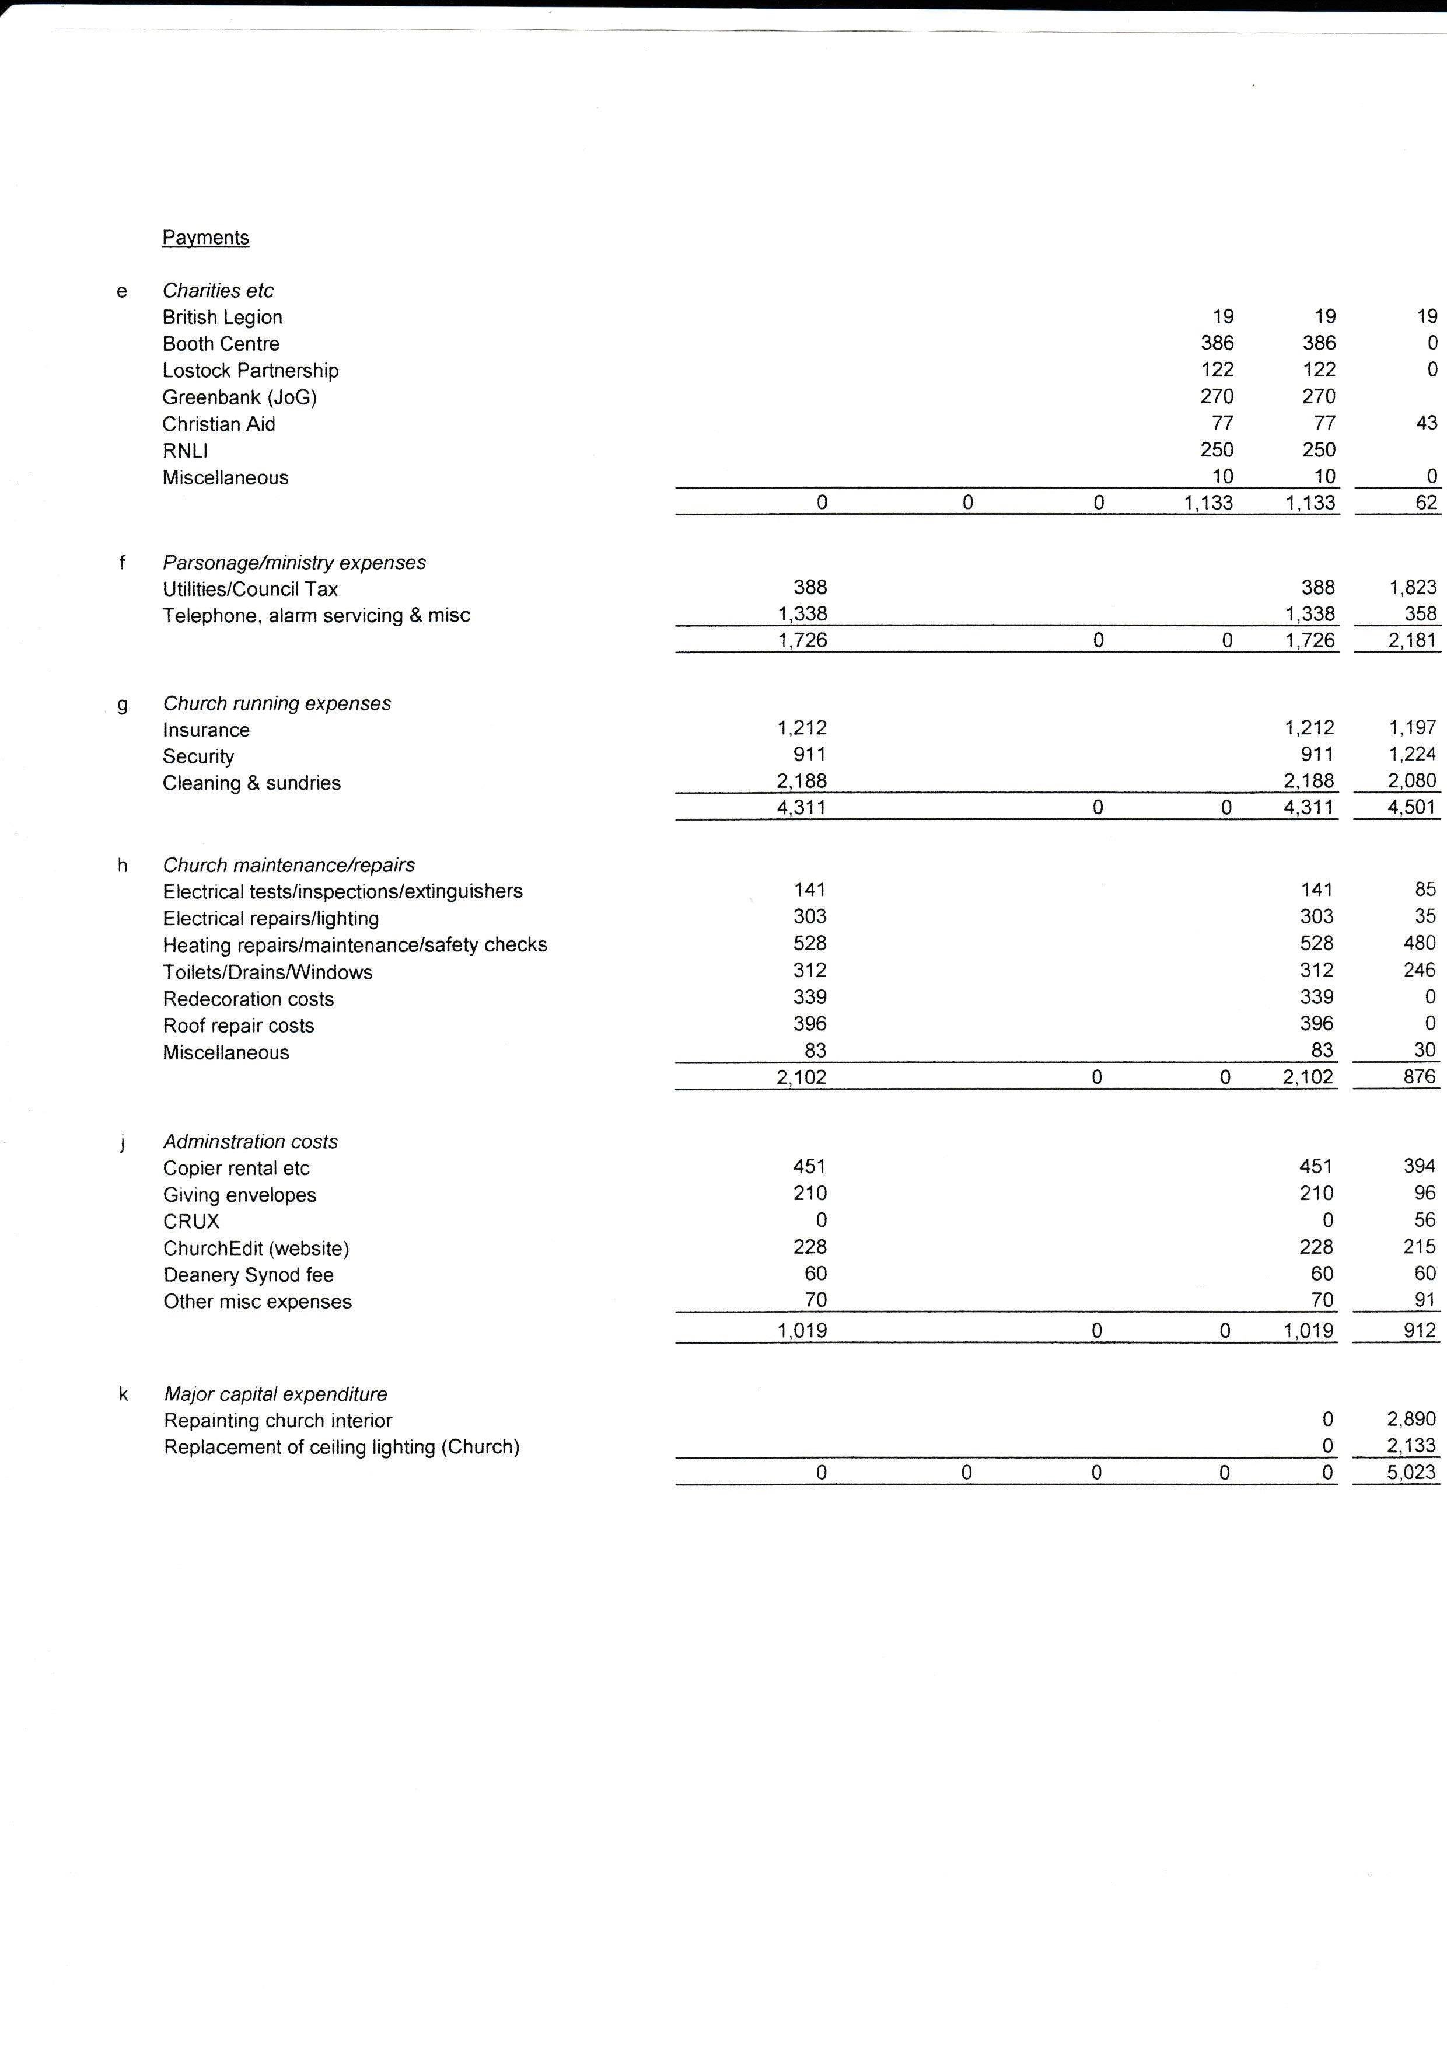
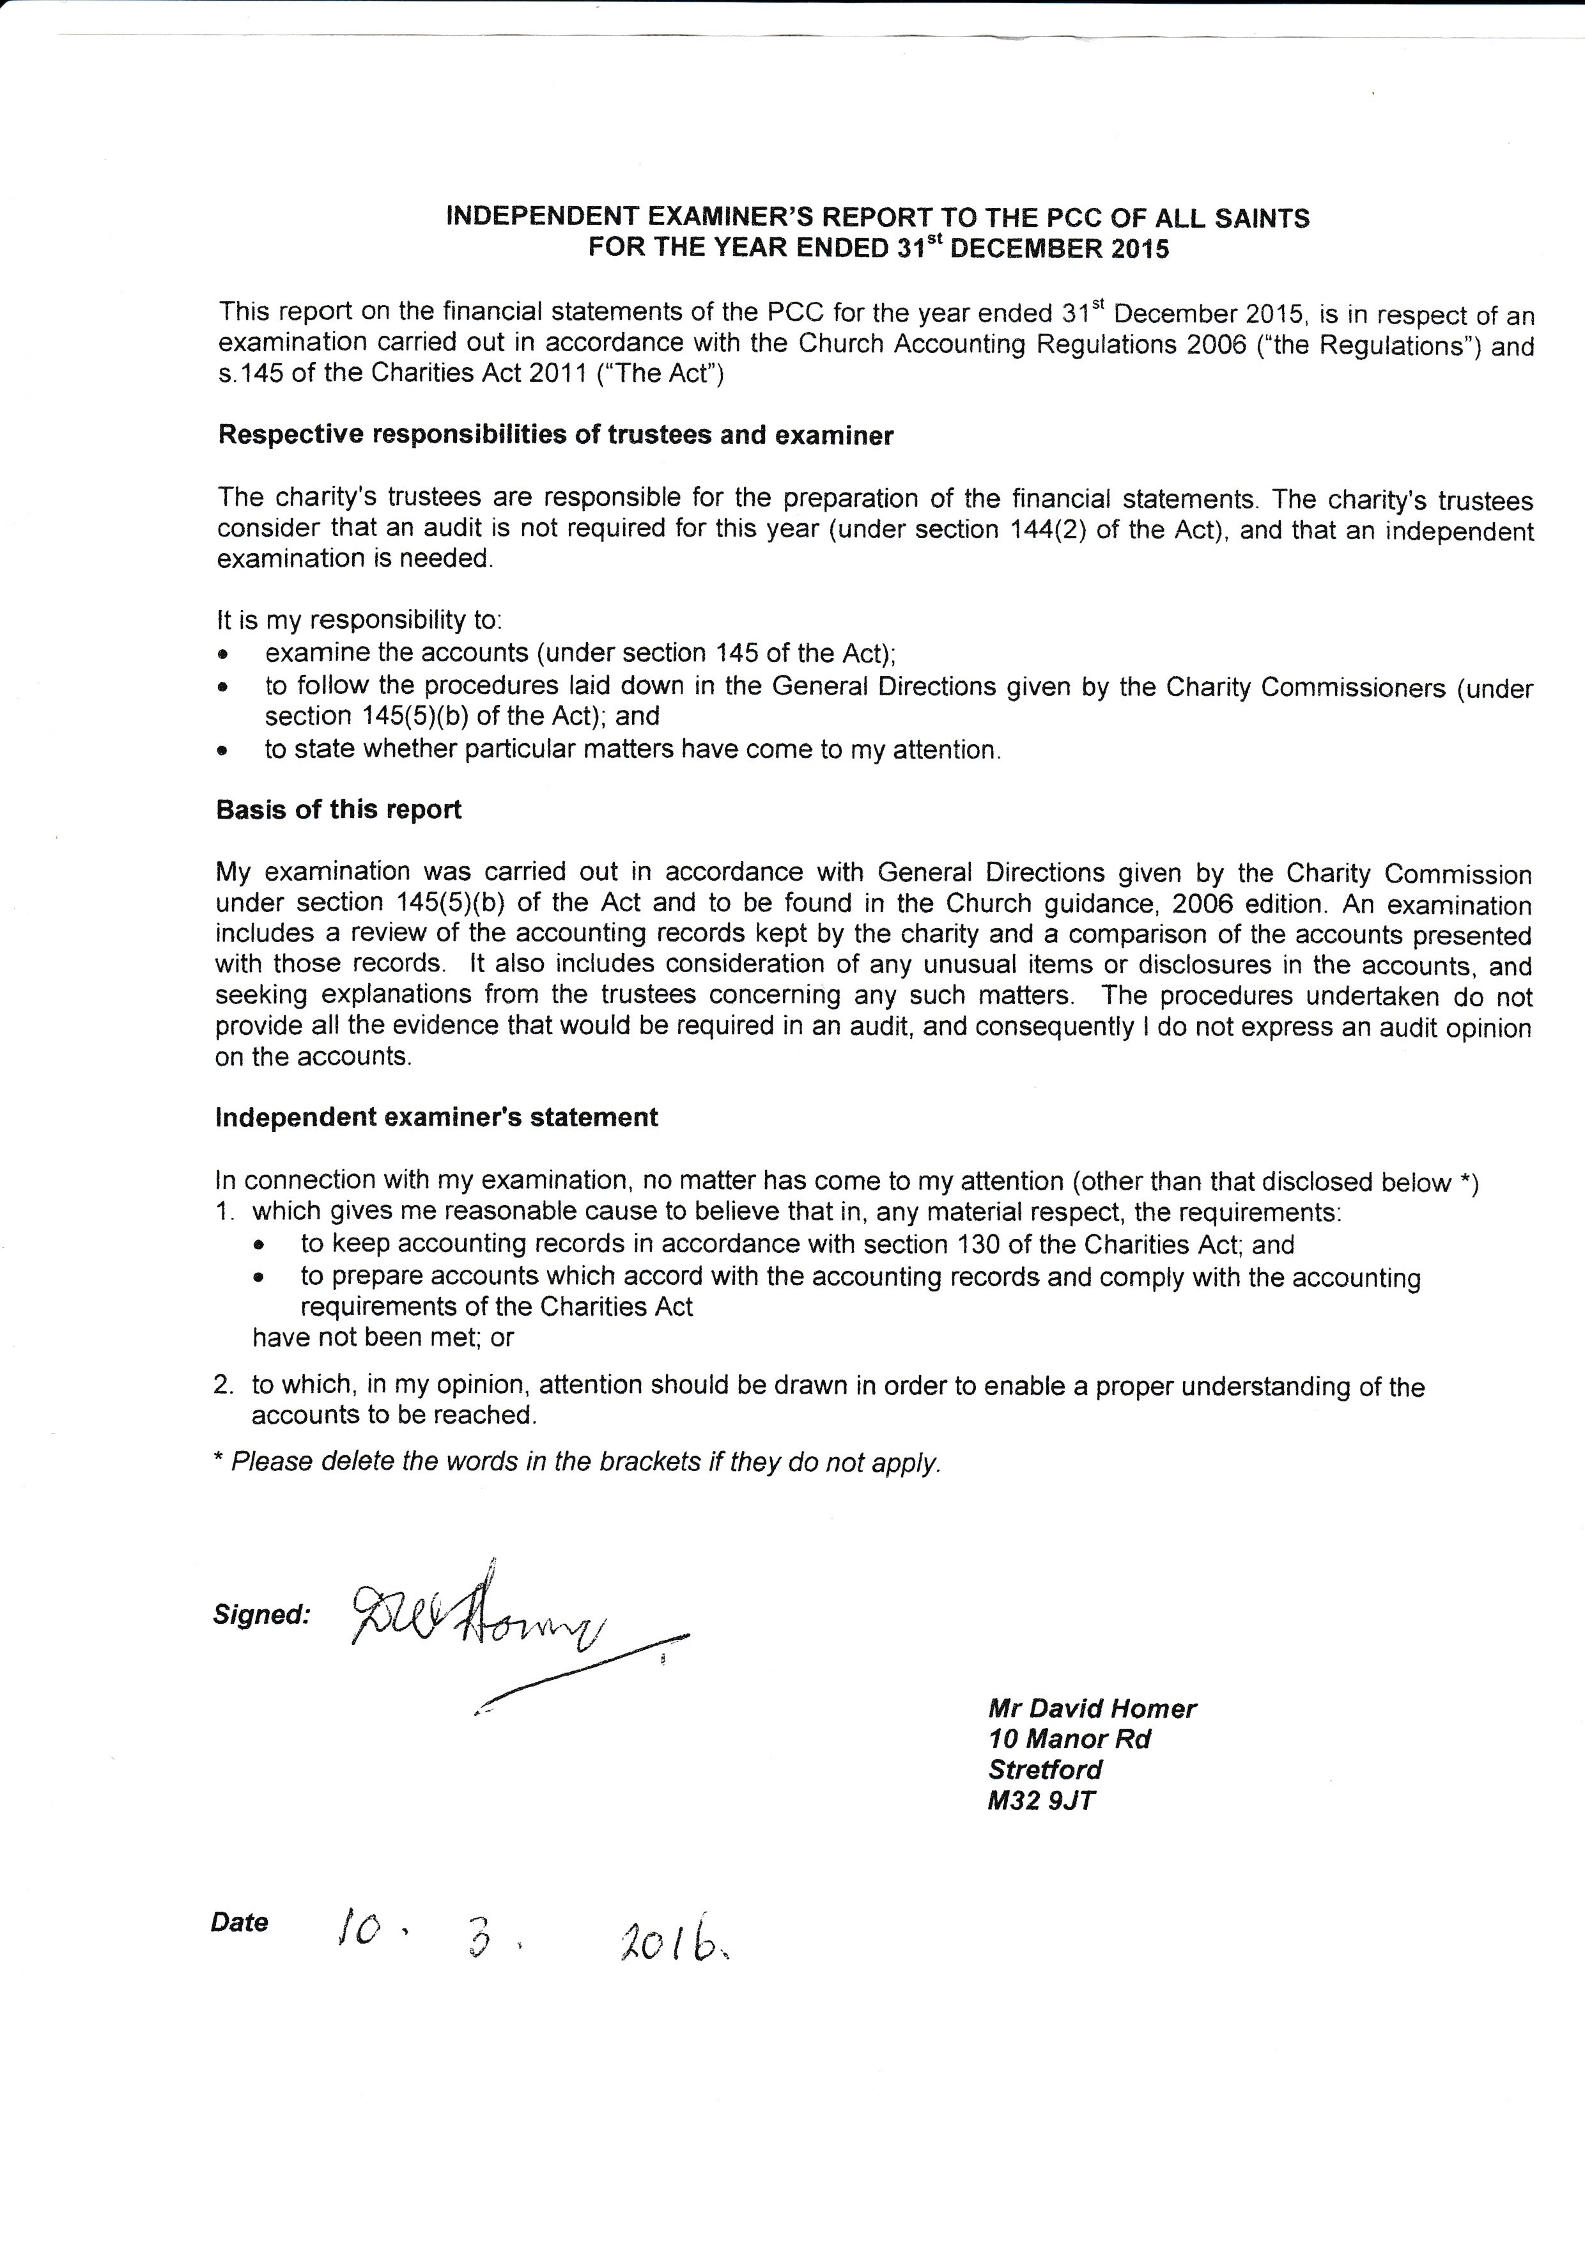

Church Wardens Report

Where do I begin for the year 2015? Of course the big question was “when do we get our new parish priest”? My reply to those who asked was always “have patience and when God sends him or her to us we must be ready in both spiritual and practical matters”. Now back to reality and parish life goes on.

All Saints made a good start to the year by paying our parish share in full showing our commitment on budget matters.

We had a “Noah” situation when various water problems gave us some concerns throughout the year and unfortunately will continue into 2016. Our housekeeping purse covers all aspects of our building, a fact that perhaps a few of us may take a little too lightly, for repairs have to be done.

In our worship we were very fortunate to have good support from visiting clergy, this was truly a blessing. We thank each one of them for their ministry and keep them in our prayers. Other services were lay lead and on occasions were quite diverse but all were received well by the congregation. It was a good opportunity to hear, share and appreciate each other’s views on our worship and fellowship.

Fund raising and joint projects throughout the year were well supported. The community fait followed by the Stretford Silver Band concert was a great success. The day gave us a real boost on just how we can join together in friendship as well as faith. A real vision to what we can achieve in the future.

All Saints continues to support various charities and projects, all donations so graciously accepted and acknowledged. We must remain committed to offer whatever we can through prayer, monitory or time to help those less fortunate than ourselves. There but for the grace of God it could be one of us.

The summer months seemed to be a busy time of preparation; at last our new priest-in-charge had been appointed. Were we ready? We were about to find out. With the arrival of a new priest imminent the Rectory was our next priority. The premises were inspected and a much needed revamp was put into action. A comfortable home would play such a large part in settling in our new church family. I owe a great debt of gratitude to everyone who gave their time and effort to keep our church and the building looking pristine and cared for. Were we ready for the licensing – yes we were!
November arrived and how well we welcomed Revd. Luke, Laura and Anna into our All Saints family. A wonderful celebration to show our total support for our new incumbent and also an enjoyable occasion for Luke and his guests. As a team you did so well, rising to the occasion proving that God listens. Everything was so good on that lovely day in November (Sunday 1st Nov 2015). At last Luke our eager incumbent was with us and it was time to begin out new journey and a fresh approach to our parish life. Our prayers had been answered. Revd Luke’s enthusiasm has had such an embracing effect on our congregation and visitors. Each of us is sensing a journey of togetherness in faith and walking every step beside him.

As Treasurer Anthony has been a great supporter of All Saints. He continued in the role as we sought to identify someone else willing to take on this position, for this we were truly grateful. I promise it was only gentle cajoling as David Morris appeared on my radar. My appeal for help was rewarded and David succumbed to my need for his time and talents – Thank you David.

Sadly we said goodbye to Dorothy Nuttall. She truly was dedicated to all areas of church life and will be missed by so many. Alas at the end of the year Gwen Archer also passed away, she was poorly for some time but is now at peace. We, as a congregation give thanks for having Dorothy and Gwen in our lives.

Now its time to show some humility. I say thank you to all of you, dear friends, who have supported me in my position as church warden. Simply, I am the first one to admit I could not have done it without each and every one of you. Help with practical matters and your words of encouragement have meant so much to me, all given with the love of God being our bond.
May the light of Jesus continue to shine upon us as we journey together in faith. My prayers are with you all.
God Bless.

Beryl Davies
Churchwarden

Parochial Church Council (PCC) Report

Meetings of the Year

During 2015 there were 9 full meetings of the PCC at which the average attendance was 77.5%. Standing meetings were held when necessary and reported back to the PCC

PCC membership for the non ex officio members which was 8 was not as large as we would like and the entire congregation must pray and discern their own involvement in both the running of our church and the work supporting Revd. Luke Maguire, providing the pastoral, evangelistic and church’s mission out in our community.

Significant Areas of Discussion

Overall 2015 had no real issues with regards to the Church, Rectory or Lomond Ave buildings. A number of various ongoing maintenance updates and tasks completed throughout the year including replacement lights in the church porch, PAT Testing, Kitchen pipe replacements, leaks in the toilets and prayer corner, and painting of the vestry and toilets. The Rectory had a Quinquennial Inspection and a number of remedial repairs identified that were completed by the Diocese, a new kitchen and boiler was also fitted once we had confirmation that our vacancy had been filled. Lomond Ave has a change of tenant, some remedial work has been completed, carpets cleaned and the new tenant moved in.

A lot of effort was put into getting all the services covered and trying to carry on as normal. The visitors provided us with a wealth of different services and sermons that we all thoroughly enjoyed and thank them for. There were a few times when we had no priest and we had to have Worship and Praise services however this proved to be a great opportunity for others to share their thoughts with the congregation. Members of the church were stepping up to fill gaps were necessary while we await a new priest-in-charge.

The appointment of Revd. Luke Maguire was a highlight and a relief for those ensuring we had cover, knowing there is light at the end of the tunnel. The 1st of November 2015 was scheduled to be the date for Luke’s licensing, everyone pulled together, getting the Rectory finished, making the church look nice and sorting the logistics for the licensing day, food, invites, hymns, service sheets it’s amazing what needs to happen. We pulled off what I think was a fantastic day and I am sure Luke and his guest also enjoyed themselves and it is a sure sign of our future together.

Legacies left to the church help us to support different project as the people who left them would wish, this year it allowed us to purchase a new piano at the start of 2016 and we thank David for playing it for us.

The PPC meeting after the APCM elected new officers, generally it was the same people, it has proven difficult for us to find a second Church warden to assist Beryl and share the responsibility of this important role. It is for each of us to pray and discern whether we should be doing more at church, hopefully this year we will be able to fill this position.

PCC meetings discuss the usual business matters, Finance, Deanery and Diocesan matters and also include other areas of discussion;

- Hall Rents
- School Visits (Lostock College, Barton Clough and Moss Park)
- Services during Lent & Holy Week
- Various Maintenance at Church and Lomond Ave Church Security
- Rectory Maintenance
- Covering Services (Sunday, Wednesday and festivals)
- Non Eucharistic services when priest not available
- Special Services, All Saints, Easter, Harvest, All Souls etc
- Fundraising
- Hall Bookings
- Charitable giving

In addition to the above the Archdeacon of Manchester had once again written to the PCC to congratulate us on our 100% Parish Share payment, a great achievement.

Looking forward we have some challenges and opportunities to engage with the community outside our doors, we will have the opportunity to take part in Mission Action Planning that is being rolled out that will help us as a parish to plan a better future. I for one am looking forward to our journey with Luke.

Church Events

There were a number of social & church events organised throughout the year. These events aim to encourage church fellowship and provide a chance to talk to people we don’t normally speak to. They are fun evenings with good food served.

- Stretford Band Concerts
- Songs of Praise
- Community Day Fair
- Community Litter Pick
- Social Evenings
- Christmas Fayre

Thanks go to all those who help me by providing additional reports from different groups and synods, Anthony for his careful monitoring of finances which allows the PCC to fund the different projects successfully, to David for agreeing to take over Anthony’s role for 2016 onwards and thanks to all the PCC members who attend meetings regularly throughout the year and help to get everything done.

Steve Worsley
PCC Secretary.

Stretford Deanery Synod Report

The Stretford Deanery Synod met four times during 2015.

At each meeting there were the usual administrative and business matters including;

- Reports on the Manchester Diocesan Synod meeting.
- Deanery Treasurer’s report.
- Deanery Budget Secretary report.
- Deanery Standing Committee reports.
- Pastoral matters affecting Stretford including reports from the Deanery Mission and Pastoral Committee on proposals for pastoral re-organisation

At each meeting the Deanery Synod also received an update on the building of a new worship centre and rectory at Saint Brides Church, Old Trafford.

At its January meeting the Deanery Synod had a presentation by James Emmerson, Diocesan Stewardship Officer. This was one of a series of visits to Deanery Synods. After his talk the Synod formed several discussion groups followed by feedback to the full Synod.

The April meeting was addressed by Revd. Steve Williams, the Diocesan Advisor on inter-faith relations. He introduced himself as a person who is recognised as the local Anglican priest in the Jewish community of Prestwich. He described inter-faith as building relationships on a personal level through an understanding of each faiths observances, calendars and histories.

The July meeting had a presentation by Mrs Cath Hilton, the President of Manchester Diocese Mothers Union. Her theme was “Turning Faith into Action” and she provided many examples of such work undertaken by members of the Mothers Union locally, nationally and internationally.

The Bishop of Manchester, Rt. Revd. David Walker attended the October meeting. This meeting was held in the evening after a full day which he had spent in the Stretford Deanery. He had visited several varied organisations and community activities, had a separate meeting with the clergy of the Deanery and at the Synod conducted a question and answer session.

At a service held at Saint Michael’s Church, Flixton on 1st September 2015 Revd. Alex Clephane, Ordained Local Minister at that church , was licensed by the Bishop of Middleton as the new Area Dean of Stretford. He has replaced Revd. John Hughes of Saint John’s Church, Old Trafford who had given six years’ excellent service as our Area Dean. The congregation of All Saints Church, Stretford is particularly grateful for his support during our 2014-2015 interregnum.

We look forward to working with Alex in the years ahead and were most interested to learn his vision of the future of the Stretford Deanery when he addresses the Deanery Synod in October at its first meeting following his appointment.

During 2015 Mrs Yvonne Mackereth was elected as the Lay Chair of the Stretford Deanery Synod. We welcome her to that post and thank her predecessor, Mr David Cooper of Saint Matthews Church, Stretford for his years of loyal service in that post.

Beryl Davies, Duncan Gilbertson and Steve Worsley
Deanery Synod Representatives

Manchester Diocesan Synod Report

The Manchester Diocesan Synod met three times during 2015. At these meetings the Synod dealt with the usual business and administrative matters:

- Reports from General Synod Members
- Reports from Diocesan Boards and Committees
- The approval of the Diocesan accounts for 2014
- The approval of the Diocesan budget for 2016
- The allocation of the Parish Share between Deaneries.

At the February and June meetings there were major debates and decisions taken on two matters;

- Parish Share
- Governance

- Following wide consultation throughout the Diocese the Synod agreed at its June meeting a revised method of calculation of Parish Share, involving consultation between the Board of Finance and individual Parish Church Councils would be introduced. However, in order to reflect the differences between parishes, the system would continue with two basic principles: the income survey and the attendance survey.
- The Synod agreed to proposals for the amendments of the systems of governance within the Diocese and the adoption of proposals for protocols to be included in a “Governance Manual”.

At its meeting in February 2015 the Synod received a report from the Mission and Ministry Department entitled “Welcoming and Belonging”. The report was introduced forcefully by the Bishop of Bolton (Rt. Revd. Chris Edmonson) and was strongly supported in his presentation by Revd. John Rosedale and Revd. Jackie Calow of the Saddleworth team Ministry.

At the February meeting of the Diocesan Synod Revd. Anne Edwards, Deputy Chair of the Diocesan Committee, introduced a debate on the subject of “Stewardship and Giving”. The debate was welcomed by Synod members and they warmly welcomed a proposal that members of congregations should review their giving to and through the church on a regular basis.

Duncan Gilbertson and Steve Worsley
Diocesan Synod Representatives

Churches Together in Stretford Report

Churches Together in Stretford (CTiS) has not been associated with Churches together in England for some time however the different churches do meet and plan different activities throughout the year. All Saints enjoys these opportunities of ecumenical fellowship and worship and takes an active part in assisting with the running of the events.

The years activities start in January with a Week of Prayer for Christian Unity, each church provided a short service in the form of evening prayer or Taize finishing with Mass at the Roman Catholic Church. This final mass highlights how far apart we are as we are unable to celebrate the Eucharist together.

Lent provides us with another great opportunity to share experiences as we travel to a different church each week, this year we started with our Pancake Party on Shrove Tuesday and an introduction to the course materials, provided by Churches Together in Britain on the subject of Christians in the Middle East a subject that is continually in our news with Syria and other troubled areas around the Middle East.

Sevenway’s hosted the World day of Prayer, devised by the women of the Bahamas focusing on what Jesus said “Do you understand what I have done for you?” Attendance of this service is not just for women it is a celebration and time of worship for everyone.

Palm Sunday service in the park, hosted by Victoria Park is proving to be a great success and a great opportunity for the churches to show themselves and working together. The service had live music from the Christian Life Worship Band and two Donkeys. Easter Eggs were passed out along with the Easter Story.

All Saints hosted a Songs of Praise and bring and share supper, bringing everyone together for a good sing song and fellowship which is always better with something to eat.

The year ends with Christmas Carols, we gather together to sing our favourite carols with members of our local community, Butler Court and Victoria Court . The finale is a Saturday morning in the Stretford Mall. This year we had donations totalling £100 and this went to the Booth Centre Charity.

Sometimes churches just open up their events to all the other churches such as BBQs, Beetle Drives and a Duodecimo Concert, these events are usually to help raise funds for the Leipzig Exchange. This year 7 visitors from Leipzig will be guests of church people in Stretford. St Matthews take the lead on this and have varied activities such as a visit to MUFC Museum during their stay. All Saints welcomed the visitors and guests on the Friday evening providing entertainment and a three course meal which was thoroughly enjoyed by everyone.

Steve Worsley
CTiS Representative

Regular Hall Users

The Church Hall is used by the community for a number of activities;

Day | Activity | Time | Rooms | Contact
Monday | Dancing Class | 4.00-7.30 | All | Lorraine  01925 572122  07468 495275
Monday | Line Dancing | 7.30-10.30 | Hall  Kitchen | Roy  07517 1389836 – text only
Tuesday | Stockdales | 6.30-9.30 | All | Alex Cox  972 0668
Wednesday | Morning service | 9.30-11.00 | Church
Wednesday | Rainbows | 5.00-6.00 | Hall, Kitchen  SMR | Laura  Laura.j.heaton@hotmail.co.uk  07814 645907
Wednesday | Brownies | 6.00-7.00 | Hall, Kitchen  SMR | Laura – as above
Wednesday | Guides | 7.00-8.30 | Hall  Kitchen  SMR | Steph  07989 642138
Thursday | Dancing Class | 4.00-6.00 | All | Lorraine – see above
Thursday | Morris Dancing | 6.30-8.30 | Hall | Michelle  Shellwoods73@outlook.com
Thursday | Craft Group | 7.30-9.00 | LMR | Sandy
Saturday | Dancing Class | 9.00-1.00 | All | Lorraine – see above
Sunday | Services | 7.30-12.00 | All

End of Report

