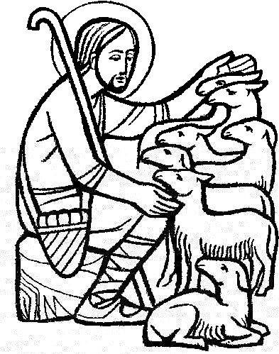
Parish of All Saints Stretford

Sunday 17th April 2016
4th Sunday of Easter

Today’s hymns are from NH&WS

Introit 17 As the deer pants for water

Gradual 18 As we are gathered

Offertory 122 I the Lord of sea and sky

Communion 6 All heaven declares

Recessional Sheet In Christ alone

Readings for today p872
Acts 9.36-43 Eva Clague
Psalm 23 Stuart Gilbertson
Revelation 7.9-17 Duncan Gilbertson
Gospel: John 10.22-30
Intercessions: Revd. Luke Maguire
Lay Assistants: Beryl Davies William Tomkinson
Sides People: Duncan Gilbertson Joan Thorley

TO REMEMBER IN OUR PRAYERS THIS WEEK

We give thanks for those who have had prayers answered and pray especially for the sick and distressed including:, Audrey Carter, Sally Duncan, Barbara Welch, Helen Cooper, Tracey Cook, Sarah Burke, Danny, Derek Fanshawe, Ruth Rogers, , Karen, Will, Max Crompton, Phil Wall, Allan Roberts, David West, Sean McGlade, Susan Fall, Chris Allen, Joan Hornby, Ros Liburd, Simon Pitt and Stephen Tomkinson.

We pray for the recently departed and especially those who have died on their own this week.

We remember those whose names appear in our Book of Remembrance this coming week including: Jason Box, Ann Peel, Rose Hampson, Dorothy Williamson and James Harris.
May they each rest in peace and rise again in glory. Amen
Psalm 23

[R] The Lord is my shepherd, I shall not be in want

The Lord is my shepherd; therefore can I lack nothing. He makes me lie down in green pastures and leads me beside still waters. [R]

He shall refresh my soul and guide me in the paths of righteousness for his name’s sake. Though I walk through the valley of the shadow of death, I will fear no evil; for you are with me; your rod and your staff, they comfort me. [R]
You spread a table before me in the presence of those who trouble me; you have anointed my head with oil and my cup shall be full. Surely goodness and loving mercy shall follow me all the days of my life, and I will dwell in the house of the Lord for ever. [R]

NEXT WEEKS SERVICEs

Mon-Thurs Morning Prayer (all welcome) 8am
Tuesday Ecumenical Prayers St Matthews 10am
Wednesday Mid-Week Eucharist 9.45am

Readings for next Sunday – (24th- 5th Sunday of Easter p876)
Acts 11.1-18 Albert Martyn
Psalm 148* Beryl Davies
Revelation 21.1-6 Mandy Tomkinson
Gospel: John 13.31-35
Intercessions: Steve Worsley
Lay Assistants: Albert Martyn Valerie Smith
Sides People: Eva Leah Sybil Topping
CHURCH CONTACTS
Priest in Charge: Revd. Luke Maguire 0161 865 1350
Churchwarden: Beryl Davies 0161 865 9380
PCC Secretary: Steve Worsley 0161 864 2069
e-mail steveworsley65@gmail.com
PCC Treasurer: David Morris
email: ascstretfordtreasurer@gmail.com
Hall Bookings: Muriel Costello, 0161 865 7171 (9-5pm Mon to Fri)
CHURCH NOTICES

CONFIRMATION COURSE: A great opportunity for everyone to discuss faith and get to know new members of the church. The programme will run for 6 sessions (Fortnightly) with a rehearsal for those actually involved in the confirmation service at the end. Sessions will be all held in the church hall and all start at 7.30pm. Make sure these dates are in your diaries.
Session 1: Tuesday 19th April
Session 2: Tuesday 3rd May
Session 3: Tuesday 17th May
Session 4: Tuesday 31st May
Session 5: Tuesday 14th June
Session 6: Tuesday 28th June
Rehearsal: Tuesday 12th July

TAIZE SERVICE: A reflective service of song and prayer @ the Martin Luther Church, Park Rd Saturday 23rd April 6pm

VOTING: A reminder that the Church Hall will be used as a Polling Station on Thursday 5th May so will be unavailable to groups.

COMMUNITY DAY: At All Saints Saturday 11th June 11am, lots of activities and stalls, see Steve for more information.

ANNUAL PARISH MEETING (APCM): TODAY!! Make sure you have completed forms in the porch for PCC and sides persons, the meeting will be after todays church service.

DEANERY SYNOD: Weds 27th April St Matthews 7.30pm

NEXT PCC MEETING: Wednesday 4th May 7pm Eucharist 7.30pm Meeting

ARCHDEACON’S VISITATION: Monday 16th May St Matthews

Sharing the love of Christ, the Light of the World,
with the people of Stretford.

Find out all about us on our website
www.allsaintsstretford.org.uk
In Christ alone my hope is found,
He is my light, my strength, my song;
This Cornerstone, this solid Ground,
Firm through the fiercest drought and storm.
What heights of love, what depths of peace,
When fears are stilled, when strivings cease!
My Comforter, my All in All,
Here in the love of Christ I stand.

In Christ alone! - who took on flesh,
Fullness of God in helpless babe.
This gift of love and righteousness,
Scorned by the ones He came to save:
Till on that cross as Jesus died,
The wrath of God was satisfied -
For every sin on Him was laid;
Here in the death of Christ I live.

There in the ground His body lay,
Light of the world by darkness slain:
Then bursting forth in glorious day
Up from the grave He rose again!
And as He stands in victory
Sin's curse has lost its grip on me,
For I am His and He is mine -
Bought with the precious blood of Christ.

No guilt in life, no fear in death,
This is the power of Christ in me;
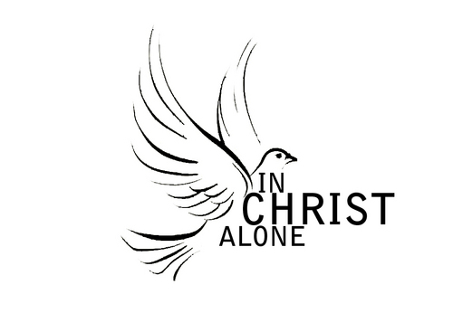
From life's first cry to final breath,
Jesus commands my destiny.
No power of hell, no scheme of man,
Can ever pluck me from His hand:
Till He returns or calls me home,
Here in the power of Christ I'll stand.

