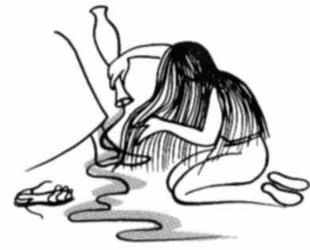
Parish of All Saints Stretford
Sunday 13th March

Fifth Sunday of Lent – Passiontide begins

Today’s Music is from Mission Praise

Introit 396 Just as I am, without one plea

Gradual 619 Such love, pure as the whitest snow
Offertory 162 From heaven you came
Communion 66 Broken for me

Recessional 755 When I survey the wondrous cross

Readings for today Passion Sunday p835

Isaiah 43.16-21 June Kettle
Psalm 126 Beryl Davies
Philippians 3.4b-14 David Starmer
Gospel: John 12:1-8
Intercessions: Steve Worsley
Lay Assistants: Valerie Smith Margaret Dawson
Sides People: Carl Horne Bea Morrow

TO REMEMBER IN OUR PRAYERS THIS WEEK

We give thanks for those who have had prayers answered and pray especially for the sick and distressed including: Ann Clancey, Barbara Welch, Helen Cooper, Tracey Cook, Sarah Burke, Danny, Derek Fanshawe, Ruth Rogers, Lennox Davidson, Karen, Will, Max Crompton, Phil Wall, Allan Roberts, David West, Sean McGlade, Sean, Susan Fall, Chris Allen, Joan Hornby, Ros Liburd, Simon Pitt and Stephen Tomkinson.

We pray for those who have passed away this week on their own

We remember those whose names appear in our Book of Remembrance this coming week including: Elizabeth Adams, Minnie Collinson, Harry Oakes, Mildred Chantrell, Sid Hughes, Madaliene Agnew, Frank Wightman, William Nuttall and Sue Wilson.

May they each rest in peace and rise again in glory. Amen
Psalm 126

[R] The Lord has done great things for us and we are glad indeed.

When the Lord restored the fortunes of Zion, then were we like those who dream. Then was our mouth filled with laughter and our tongue with shouts of joy. [R]

Then they said among the nations, ‘The Lord has done great things for them.’ The Lord has done great things for us, and we are glad indeed. [R]

Restore our fortunes, O Lord, like the watercourses of the Negev. Those who sowed with tears shall reap with songs of joy. Those who go out weeping, carrying the seed, will come again with joy, shouldering their sheaves. [R]

THIS WEEKS SERVICES

Mon-Thurs Morning Prayer (all welcome) 8am
Tuesday Ecumenical Prayers St Matthews 10am
(NOTE: No Prayers on Tues 22nd and 29th March)
Wednesday Mid-Week Eucharist 9.45am

Readings for next week – (Sun 20th Mar) Liturgy of Palms p840
Philippians 2.5-11 Eva Clague
Gospel: Luke 22.14 - 23.56
Intercessions: Valerie Smith
Lay Assistants: Billy Tomkinson Albert Martyn
Sides People: Billy Tomkinson Margaret Graham

A prayer for victims of modern slavery

God of justice, who called your people out of slavery to freedom in the promise land, hear the cry of the victims of slavery in every place and generation.
Forgive our tolerance of the structures that imprison people today, and give us grace to speak for those who have no voice and to work for the freedom of all; through your Son, Jesus Christ, who took the form of a slave but lives and reigns with the Holy Spirit in the unity of love. Amen
CHURCH NOTICES

LENT LUNCH: The last of our Lent Lunches is this week – Wed 16th March 12-1pm

CTiS 2016 LENT STUDY: The final study session will be on Thursday 17th Mar @ All Saints, we will welcome Nigel back and we will have the opportunity to listen to refugees stories and have time to ask questions, along with looking at how climate change affects how people are moving around the world.

COMMUNITY LITTER PICK: TODAY after the service, Bacon/Sausage barms afterwards. It is great for the church to get out in the community as well as cleaning up around the church gardens and be seen to be helping our parish. All equipment will be provided – Pickers, Bags and high-vis jackets.

HOLY WEEK PROGRAMME: - Sunday 20th to Sunday 27th March
Sunday 20th – Palm Sunday 10am / CTiS Victoria Park 3pm
Monday – Compline with Address 7.30pm
Tuesday – Agape meal with prayers 7.30pm
Wednesday – Taize Prayers 7.30pm
Maundy Thursday - Holy Eucharist (watch until midnight) 7.30pm
Good Friday – Liturgy of Good Friday 2pm
Easter Sunday – Easter Vigil/Breakfast 7am – Family Service 10am
WALSINGHAM PILGRIMAGE 2016: £10 Deposit is required ASAP. 16 places have been reserved at the Shrine (Mon26th to Thursday 29th Sept). More details will follow, if you would like to go please speak to Steve,

ANNUAL PARISH MEETING (APCM): The meeting will be held after church on Sunday 17th April (11.30am) – Everyone is welcome and encouraged to attend.
DEANERY SYNOD: Weds 27th April St Matthews

ARCHDEACON’S VISITATION: Monday 16th May St Matthews
For more details of events please check out our website:
www.allsaintsstretford.org.uk
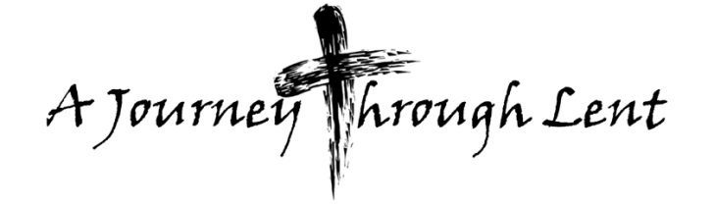
Community groups @ CHURCH

Are you looking to get involved?

Rainbows – laura.j.heaton@hotmail.co.uk
MOB: 07814 645907
Brownies – laura.j.heaton@hotmail.co.uk
MOB: 07814 645907
Guides - Steph MOB: 07989 642138

Dance – Lorraine MOB: 07468 495275

Sharing the love of Christ, the Light of the World,
CHURCH CONTACTS
Priest in Charge: Revd. Luke Maguire 0161 865 1350
Churchwarden: Beryl Davies 0161 865 9380
PCC Secretary: Steve Worsley 0161 864 2069
e-mail steveworsley65@gmail.com
PCC Treasurer: David Morris
email: ascstretfordtreasurer@gmail.com

Weddings, Reading of Banns, Baptisms and other matters may be arranged by contacting the Churchwarden or Secretary above.

The church hall can be used as a meeting place or as a venue for your party? The hall is available for single events or regular meetings. Enquiries about booking the church-hall can be made by ringing the
Hall Booking Secretary Mon-Fri 9am-5pm (Muriel - 865 7171).

Find out all about us on our website
www.allsaintsstretford.org.uk
with the people of Stretford.

NOTICE SHEET: Please let Steve know of any suggestions for the Notice Sheet. All submissions are to be in by Friday of each week contact details above.

