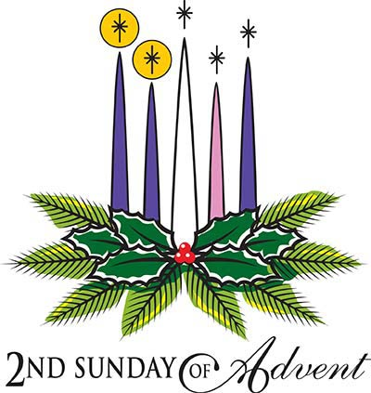
Parish of All Saints Stretford

Sunday 6th December

Advent
Today’s Music is from New Hymns and Worship Songs
Introit 28 Blesses Assurance
Gradual 166 Lord the light of your love
Offertory 91 Great is thy faithfulness
Communion 224 purify my heart
Recessional 258 The spirit lives to set us free

Readings for today – p759
Malachi 3.1-4 Billy Tomkinson
Canticle Luke 1.68-79 Bea Morrow
Philippianes 1.3-11 Mandy Tomkinson
Luke 3.1-6
Intercessions: Valerie Smith
Lay Assistants: Albert Martyn Margaret Dawson
Sides People: Duncan Gilbertson Joan Thorley

TO REMEMBER IN OUR PRAYERS THIS WEEK

We pray for the sick and distressed and especially for: Liz Palmer, Lennox Davidson, Esther MacCormack, Connor Leah, Karen, Will, Max Crompton, Mark Davies, Phil Wall, Allan Roberts, David West, Mark Roberts, Sean McGlade, Sylvia Brown, Sean, Gwen Archer, Susan Fall, Chris Allen, Joan Hornby, Ros & Des Liburd, Simon Pitt and Stephen Tomkinson.

We pray for the recently departed especially remembering Frieda Maguire and family and friends who have been saddened by her death.

We pray for those whose names appear in our Book of Remembrance including: Hilda Holingworth, Frank Urmson, Martha Crockett, Ellen Warburton, Beatrice Clarke and Frederick Bell.

May they each rest in peace and rise again in glory. Amen
Canticle Luke 1.68-79

[R] Blessed be the Lord, who sets his people free

.Blessed be the Lord the God of Israel, for he has come to his people and set them free. He has raised up for us a mighty saviour, born of the house of his servant David. [R]

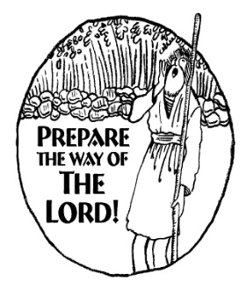
Through his holy prophets he promised of old that he would save us from our enemies, from the hands of all that hate us. He promised to show mercy to our fathers, and to remember his holy covenant. [R]

This was the oath he swore to our father Abraham: to set us free from the hands of our enemies, free to worship him without fear, holy and righteous in his sight all the days of our life. [R]

You my child shall be called the prophet of the Most High, for you will go before the Lord to prepare his way, to give his people knowledge of salvation by the forgiveness of all their sins. [R]

In the tender compassion of our God the dawn from on high shall break upon us, to shine on those who dwell in darkness and the shadow of death, and to guide our feet into the way of peace. [R]
THIS WEEKS SERVICES

Mon-Thurs Morning Prayer (all welcome) 8am
Tuesday Ecumenical Prayers 10am St Matthews
Wednesday Mid-Week Eucharist 9.45am

Readings for Next Sunday 13th December – The Third Sunday of Advent p762
Zephaniah 3.14-20 June Kettle
Canticle Isaiah 12.2-6 Stuart Gilbertson
Philippianes 4.4-7 David Starmer
Luke 3.7-18
Intercessions: Beryl Davies
Lay Assistants: Valerie Smith Beryl Davies
Sides People: Eva Leagh Sybil Topping

CHURCH NOTICES

STRETFORD SILVER BAND : Tickets are available from Steve/Beryl for the Stretford Band Christmas Concert, this year we will have festive music and carols to sing-a-long to. Saturday 19th December 7.30pm Tickets £5.00 – Selling fast…..

CHRISTMAS GRAND DRAW - As usual we shall be having a Christmas Draw to raise money and tickets are now available for you to buy and also to sell to your friends and family. Any donations of prizes over the next few weeks would be appreciated, specifically bottles of wine/spirits and boxes of chocolates and biscuits please. The draw will take place after the Carol Concert on Sunday 20th December. Please see Stuart for further details.
CTiS CAROL SINGING: Everyone is welcome to attend. Dates as follows Tuesday 15th Dec 6.30pm Butler Court, Wednesday 16th 6.30pm Victoria Court, Saturday 19th 10am Stretford Mall (Bottom of the stairs). See Steve for details.

All Saints Christmas Services
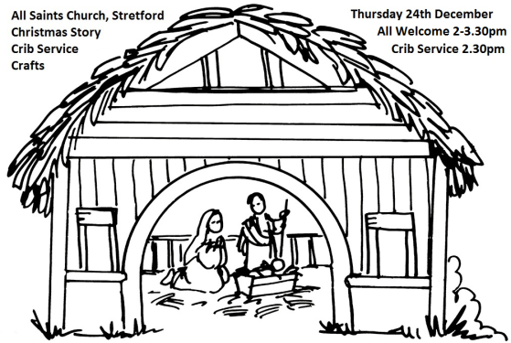
Carols by Candlelight
Sunday 20th December 4pm

Christmas Story / Crib Service / Crafts - Thurs 24th Dec 2-3.30pm

Midnight Mass
Thurs 24th December 11.30 pm

Christmas Day Service 10am

Sharing the love of Christ, the Light of the World, with the people of Stretford

CHURCH CONTACTS
Churchwarden: Beryl Davies 0161 865 9380
PCC Secretary: Steve Worsley 0161 864 2069
e-mail steveworsley65@gmail.com
PCC Treasurer: Anthony Slack
e-mail antslack@btinternet.com

Weddings, Reading of Banns, Baptisms and other matters may be arranged by contacting the Churchwarden or Secretary above.

The church hall can be used as a meeting place or as a venue for your party? The hall is available for single events or regular meetings. Enquiries about booking the church-hall can be made by ringing the
Hall Booking Secretary Mon-Fri 9am-5pm (Muriel - 865 7171).

Find out all about us on our website
www.allsaintsstretford.org.uk
Christmas Appeal

The Booth Centre helps homeless people move off the streets, find new homes and get back into work. We depend on donations from the public and Christmas is a time when homeless people need our help more than ever.
Please support our Christmas appeal by donating:
- Men’s toiletries – deodorant, toothpaste, tooth brushes, soap
- Hats, gloves and thick socks
- Individually wrapped Cakes, biscuits and chocolates
- Financial donations
See Duncan / Steve for more information. Items may be left at the back of church in the box provided.

