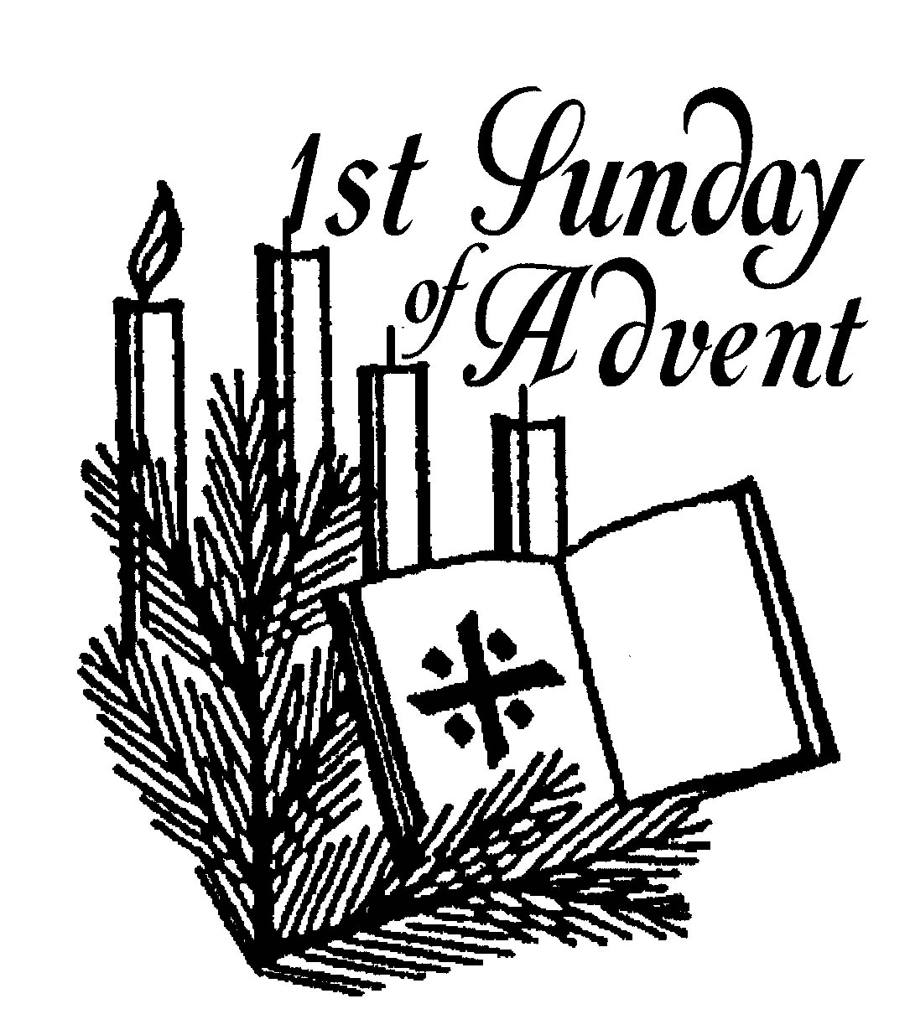
Parish of All Saints Stretford

Sunday 29th November

Advent
Today’s Music is from the Mission Praise Hymn Book
Introit 271 To God be the glory
Gradual 17 As the deer pants for water
Offertory 83 God is working his purpose out
Communion 22 Be still and know that I am God
Recessional 40 Colours of Day

Readings for today – p755
Jeremiah 33.14-16 Eva Clague
Psalm 25.1-9 Beryl Davies
1 Thessalonians 3.9-13 Duncan Gilbertson
Luke 21.25-36
Intercessions: Steve Worsley
Lay Assistants: Valerie Smith Billy Tomlinson
Sides People: Margaret Bishop June Kettle

TO REMEMBER IN OUR PRAYERS THIS WEEK

We pray for the sick and distressed and especially for: Liz Palmer, Lennox Davidson, Esther MacCormack, Connor Leah, Karen, Joanne Macholc (nee Thorpe), Will, Max Crompton, Mark Davies, Phil Wall, Allan Roberts, David West, Mark Roberts, Sean McGlade, Sylvia Brown, Sean, Gwen Archer, Susan Fall, Chris Allen, Joan Hornby, Ros & Des Liburd, Simon Pitt and Stephen Tomkinson.

We pray for the recently departed especially those who have died this week on their own.

We pray for those whose names appear in our Book of Remembrance including: May Bardsley, Horace Tomlnson, James Jones, Albert Bell, Betty Thornton, Frank Robinson and Nellie Worswick (Topping).

May they each rest in peace and rise again in glory. Amen
PSALM 25.1-9

[R] To you, O Lord, I lift up my soul.

To you, O Lord, I lift up my soul; my God, I put my trust in you;
let me not be humiliated, nor let my enemies triumph over me. Let none who look to you be put to shame; let the treacherous be disappointed in their schemes. [R]
Show me your ways, O Lord, and teach me your paths. Lead me in your truth and teach me, for you are the God of my salvation; in you have I trusted all the day long. [R]
Remember, O Lord, your compassion and love, for they are from everlasting. Remember not the sins of my youth and my transgressions; remember me according to your love and for the sake of your goodness, O Lord. [R]
Gracious and upright is the Lord; therefore he teaches sinners in his way. He guides the humble in doing right and teaches his way to the lowly. [R]

All the paths of the Lord are love and faithfulness to those who keep his covenant and his testimonies. For your name’s sake, O Lord, forgive my sin, for it is great. [R]
THIS WEEKS SERVICES

Mon-Thurs Morning Prayer (all welcome) 8am
Tuesday Ecumenical Prayers 10am St Matthews
Wednesday Mid-Week Eucharist 9.45am

Readings for Next Sunday 6th December – The Second Sunday of Advent p759
Malachi 3.1-4 Billy Tomkinson
Caticle Luke 1.68-79 Bea Morrow
Philippianes 1.3-11 Mandy Tomkinson
Luke 3.1-6
Intercessions: Valerie Smith
Lay Assistants: Albert Martyn Margaret Dawson
Sides People: Duncan Gilbertson Joan Thorley

Sharing the love of Christ, the Light of the World, with the people of Stretford
CHURCH NOTICES

CHURCH FAIR: A big thank you to all who helped and donated. Even with the weather it was a great success with £950.39 made on the day and donations still coming in. There are items at the back of church that can still be bought.
STRETFORD SILVER BAND : Tickets are available from Steve/Beryl for the Stretford Band Christmas Concert, this year we will have festive music and carols to sing-a-long to. Saturday 19th December 7.30pm Tickets £5.00

CHRISTMAS GRAND DRAW - As usual we shall be having a Christmas Draw to raise money and tickets are now available for you to buy and also to sell to your friends and family. Any donations of prizes over the next few weeks would be appreciated, specifically bottles of wine/spirits and boxes of chocolates and biscuits please. The draw will take place after the Carol Concert on Sunday 20th December. Please see Stuart for further details.
CTiS CAROL SINGING: Everyone is welcome to attend. Dates as follows Tuesday 15th Dec 6.30pm Butler Court, Wednesday 16th 6.30pm Victoria Court, Saturday 19th 10am Stretford Mall (Bottom of the stairs). See Steve for details.

All Saints Christmas Services
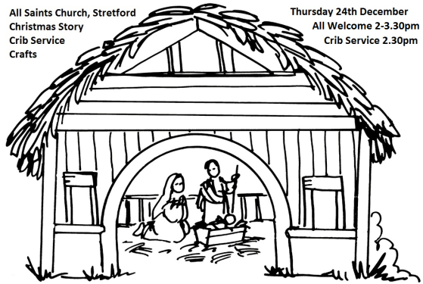
Carols by Candlelight
Sunday 20th December 4pm

Christmas Story / Crib Service / Crafts - Thurs 24th Dec 2-3.30pm

Midnight Mass
Thurs 24th December 11.30 pm

Christmas Day Service 10am
CHURCH CONTACTS
Churchwarden: Beryl Davies 0161 865 9380
PCC Secretary: Steve Worsley 0161 864 2069
e-mail steveworsley65@gmail.com
PCC Treasurer: Anthony Slack
e-mail antslack@btinternet.com

Weddings, Reading of Banns, Baptisms and other matters may be arranged by contacting the Churchwarden or Secretary above.

The church hall can be used as a meeting place or as a venue for your party? The hall is available for single events or regular meetings. Enquiries about booking the church-hall can be made by ringing the
Hall Booking Secretary Mon-Fri 9am-5pm (Muriel - 865 7171).

Find out all about us on our website
www.allsaintsstretford.org.uk
Christmas Appeal

The Booth Centre helps homeless people move off the streets, find new homes and get back into work. We depend on donations from the public and Christmas is a time when homeless people need our help more than ever.
Please support our Christmas appeal by donating:
- Men’s toiletries – deodorant, toothpaste, tooth brushes, soap
- Hats, gloves and thick socks
- Individually wrapped Cakes, biscuits and chocolates
- Financial donations
See Duncan / Steve for more information. Items may be left at the back of church in the box provided.

