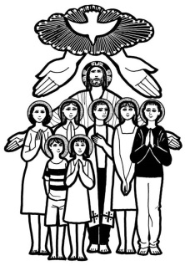
Parish of All Saints Stretford

Sunday 1st November -
All Saints Day (The Fourth Sunday before Advent)
The hymns at 10 a.m. are from Mission Praise Hymn Book
41 At the name of Jesus
54 Bind us together Lord
59 Blessed assurance Jesus is mine
1 A new commandment
148 For all the Saints

Readings for today – All Saints Day p419
Isaiah 56.3-8 Billy Tomkinson
Psalm 33.1-5 Eva Clague
Hebrews 12.18-24 Mandy Tomkinson
Matthew 5.1-12
Intercessions: Beryl Davies
Lay Assistants: Albert Martyn Beryl Davies
Sides person: Carl Horne Bea Morrow

TO REMEMBER IN OUR PRAYERS THIS WEEK
We pray for the sick and distressed and especially for: Esther MacCormick, Connor Leagh, Karen, Joanne Macholc (nee Thorpe), Will, Max Crompton, Mark Davies, Phil Wall, Allan Roberts, David West, Mark Roberts, Sean McGlade, Sylvia Brown, Sean, Gwen Archer, Susan Fall, Chris Allen, Joan Hornby, Ros & Des Liburd, Simon Pitt and Stephen Tomkinson.

We pray for those who have died on their own this week.

We pray for those whose names appear in our Book of Remembrance including: John Kitto, Winifred Crowe, Brian Silvers, Mary Saunders, Ethel Baines, Joyce Lloyd, Bertha Naylor, Joseph Houghton, Elsie Blackwell, Miriam Costello and Robert Collinson.

May they each rest in peace and rise again in glory. Amen
PSALM 33

[R] The Lord spoke to him face to face as one speaks to a friend

Rejoice in the Lord, you righteous; it is good for the just to sing praises. Praise the Lord with the harp; play to him upon the psaltery and lyre. Sing to him a new song; play to him with all your skill upon the trumpet. [R]

For the word of the Lord is right, and all his works are sure. He loves righteousness and justice; the loving-kindness of the Lord fills the whole earth. [R]

THIS WEEKS SERVICES

Wednesday 9.45am Mid-Week Eucharist

Readings for Next Sunday 8th Nov – Remembrance Sunday (Third Sunday before Advent) p739
Jonah 3.1-5,10 David Starmer
Psalm 62.5-12 Duncan Gilbertson
Hebrews 9.24-28 Albert Martyn
Mark 1.14-20
Intercessions: June Kettle
Lay Assistants: Valerie Smith Margaret Dawson
Sides person: Billy Tomkinson Margaret Graham
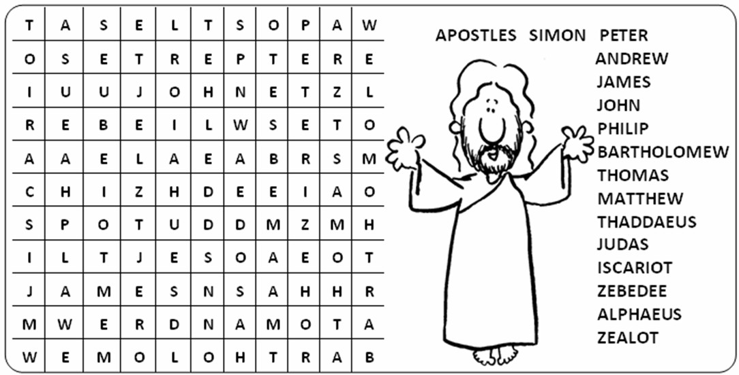
CHURCH NOTICES

Church and Lostock Partnership Pamper Day: Will be held in the church hall on Sat 14th November 3-5pm – Entrance will be £3 (Free glass of wine/cake), all proceeds will be split between the church and partnership. It will be a great afternoon to see different treatments and a good chance to buy some Christmas presents. (Stalls: Avon, Bodyshop, Tiffany’s Nails, head massage, yoga demo, eyebrows tints and lashes ….more to follow). Contact Mandy for more details.

All Souls Service: Monday 2nd November 7.30pm, there will be a form in porch to add the names you would like to be read out during the service.

Church Christmas Fair: This will be a traditional church fair and held in the church hall on Saturday 28th November 11-2pm.

Christmas Appeal
The Booth Centre helps homeless people move off the streets, find new homes and get back into work. We depend on donations from the public and Christmas is a time when homeless people need our help more than ever.
Please support our Christmas appeal by donating:
- Men’s toiletries
- Hats, gloves and socks
- Cakes, biscuits and chocolates
- Financial donations
- See Duncan / Steve for more information.
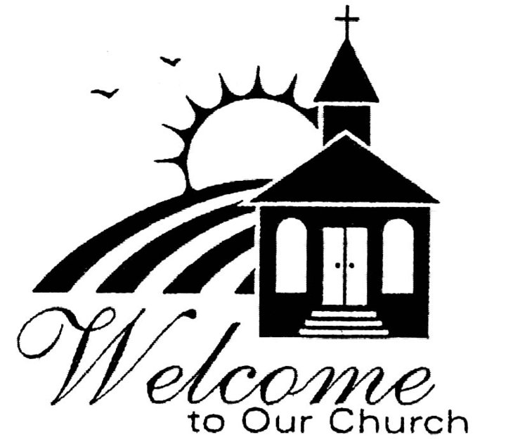
***
Welcome to our worship, especially if you are visiting or joining us for the first time. We hope that you will feel at home and will join us for refreshments after the 10am service in the Church Hall.
There is an induction loop for the hard of hearing. Please turn to T on your hearing aid. Please let a sides person know if you have any problems.
CHURCH CONTACTS
Churchwarden: Beryl Davies 0161 865 9380T%

PCC Secretary: Steve Worsley 0161 864 2069
e-mail steveworsley65@gmail.com

PCC Treasurer: Anthony Slack
e-mail antslack@btinternet.com

Weddings, Reading of Banns, Baptisms and other matters may be arranged by contacting the Churchwarden or Secretary above.

The church hall can be used as a meeting place or as a venue you’re your party? The hall is available for singles events or regular meetings. Enquiries about booking the church-hall can be made by ringing the
Hall Booking Secretary Mon-Fri 9am-5pm (Muriel - 865 7171).

Find out all about us on our website www.allsaintsstretford.org.uk

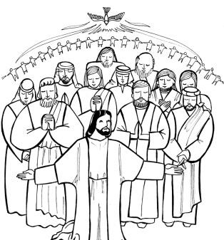
All Saints Day
From its earliest days, the Church has recognized as its foundation stones those heroes of the faith whose lives have excited others to holiness and has assumed a communion between the Church on earth and the Church in heaven.
Celebrating the feast of All Saints began in the fourth century. At first, it was observed on the Sunday after the feast of Pentecost; this was to link the disciples who received the gift of the Holy Spirit at Pentecost, the foundation of the Church, with those who were martyrs, giving their lives as witnesses to the faith. In the eighth century, a pope dedicated a chapel to All Saints in St Peter’s at Rome on 1 November. Within a century, this day was observed in Britain and Ireland as All Saints’ Day.

