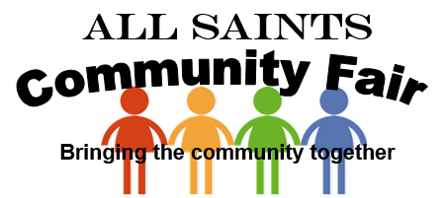
What a fantastic weekend, meeting friends from Leipzig, the Community Fair and a summer band concert. Great opportunities for meeting new people and getting to know friends better. Fundraising for the church was boosted as the fair raised a fantastic £977.59 (at the time of writing this). A great big thank you to everyone who donated or helped in any way to make the fair the great success it was. A special thank you to all the groups involved with stalls or who put on great performances, the enthusiasm shown by everyone was second to none, groups included; Friends of Delamere School, Lostock Partnership, Lostock College PA, Rainbows/Brownies/Guides, Sapphire Morris Dancers, Amy Weston, Lostock Allotments, Dione’s Nail Art, Craft Groups and All Saints.

After a glorious week of sunshine we woke up on Saturday morning to rain, rain and more rain, who could believe it? Final preparations were done, bunting and balloons put outside, a few minor technical difficulties with the gazebo’s and BBQ to overcome however at 11am we were ready to go. Due to the weather the start was very slow, the rain stopped, the sun came out and so did the people, excellent – prayer does help.

A constant stream of people provided stalls with ample opportunities and a great day was had by all by all the comments received, lots of networking and building new relationships with other parts of our community, I’m sure we have made some new friends.

With the sun out people enjoyed sitting outside, refreshments provided by the BBQ or the indoor café (Thanks Rebecca and June). The Allotment society provided a seasonal display of vegetables and information and the kids enjoyed Tin Can Alley and the Bouncy Castle while getting their faces painted. Inside there were many stalls including handmade crafts, tombola’s, cakes, jams, sweets, toys and entertainment every so often by some of the church hall users.

In church we had a great wedding exhibition and details of the Trinity Window. The day was a fantastic day of fundraising, family entertainment and church outreach. The evening was spent listening to some great tunes – what a day!
I’m already being asked about next year – BIGGER AND BETTER for sure!!!!

Amy and Joe on the Ukulele Bottle Stall Donations from Trafford Social
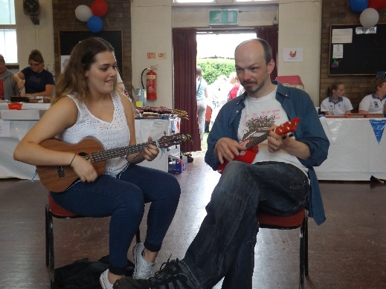

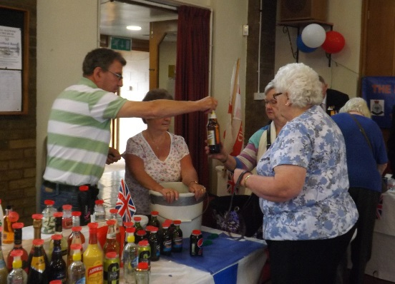

Lostock Partnership and Dione’s Nail Art

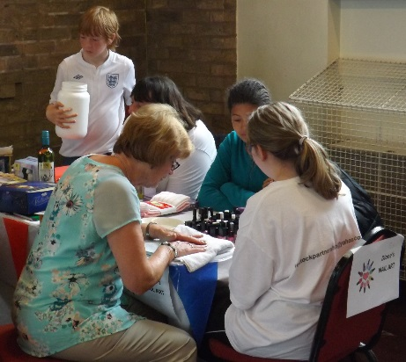
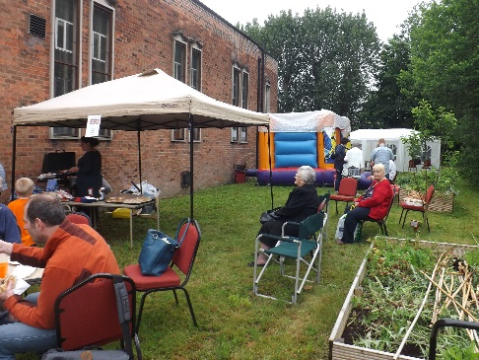

Outdoor Activities included

Tin Can Alley, Bouncy Castle, BBQ and the Allotment Society which seemed all very busy throughout the day.
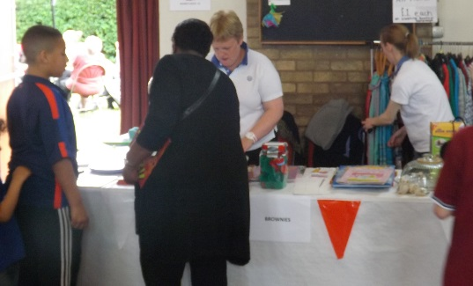
Rainbows and Brownies

Bric-a-Brac and
Jolly Jars went down very well.

Lostock College Chocolate Tombola
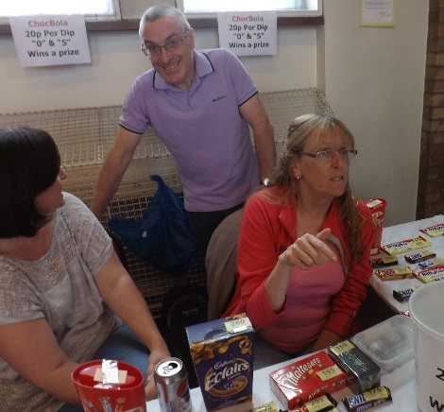

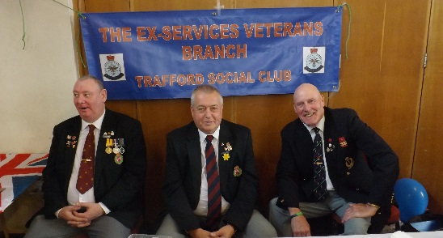
Ex Services Veterans

Bootcamp – A good laugh keeping fit, lots of red faces afterwards.
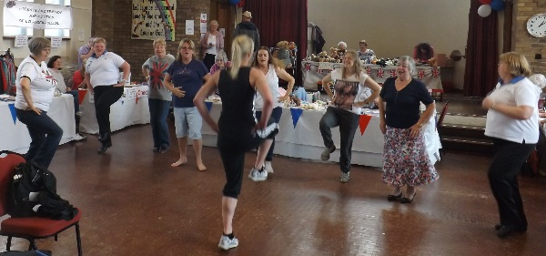
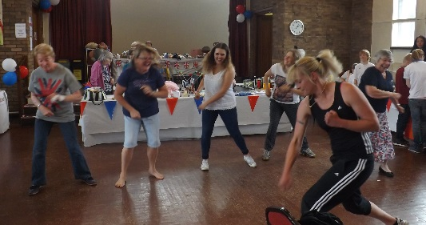

Allotment Society Sapphire Morris Dancers
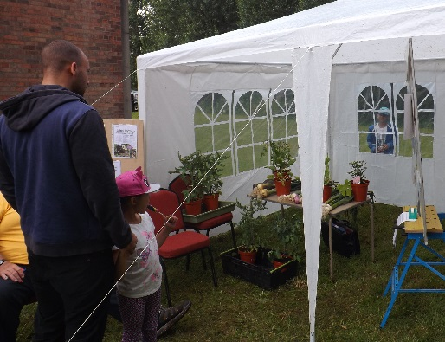
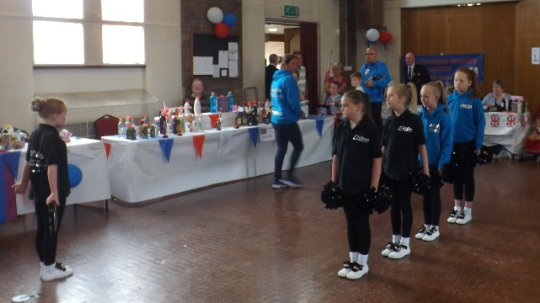

More info on the Church Web Page - http://www.allsaintsstretford.org.uk/
Church Wedding Exhibition

Many thanks to Nancy Jane Brides (http://www.nancyjanebrides.co.uk) for donating the wedding dress and flower girl.

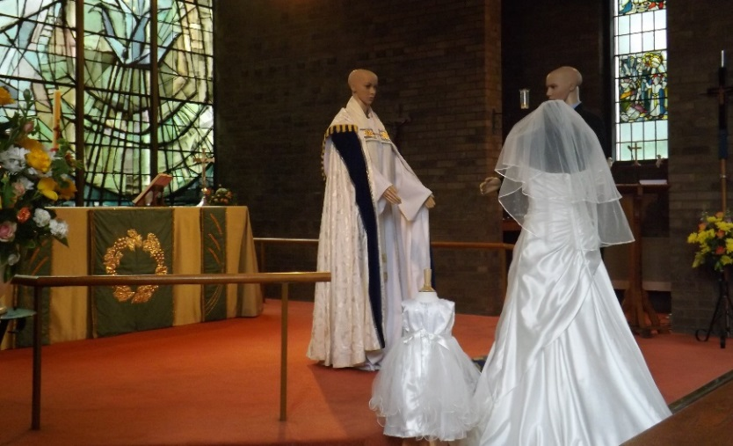

Thanks to everyone who made the church look fantastic with flowers the exhibition provided a great attraction and talking point. Many people actually went into church and said how beautiful our church actually is and a perfect backdrop of the Trinity Window – very special.

All Saints Stretford Silver Band Summer Concert

This has to be the best concert we have had here at All Saints, a pick and mix of well-known foot tapping music with some great sing- a- longs. £201 raised for the Booth Centre – Well done Bea!!! The concert raised £140 from the share of ticket sales towards church funds.
