
ALL SAINTS
Community Fair
Bringing the community together


Saturday 13th June 2015
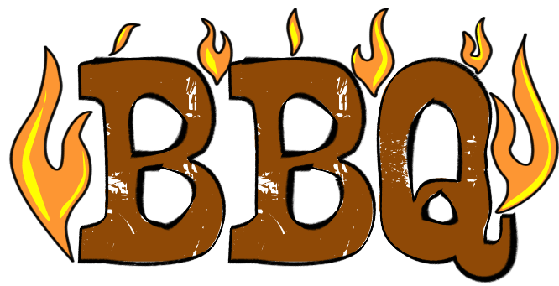
11am to 3pm

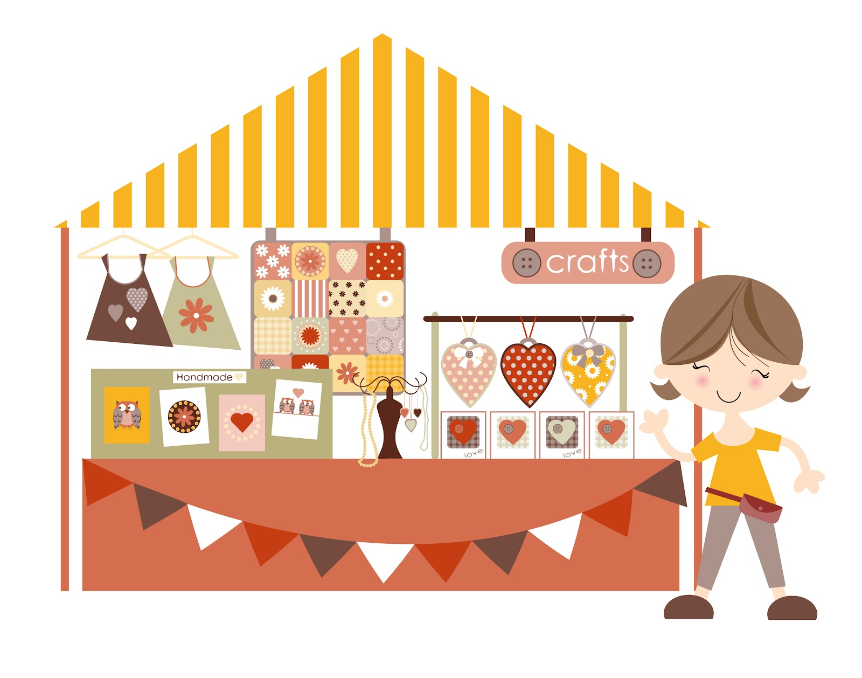
Lots of Stalls and Activities

Everyone Welcome
F riends of Delamere School,
Rainbows, Brownies & Guides
Ex Services Branch, Lostock Partnership, Lostock College PA, Craft Group, Outdoor Games, Café, BBQ, Bouncy Castle and Planetarium.
Exhibitions from Keep Fit, Line Dancing, Morris Dancing and Ukulele Music.
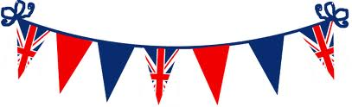
Stalls – Crafts, Cakes, Bric-a-Brac, Cream Teas, Sweets, Jams, Plants, Toys, Kids Tombola, Bottle Tombola, Good as New, Planetarium, Face Painting, Plants, Dion’s Nail Art
All Saints, Barton Rd, Stretford

ALL SAINTS
Community Fair
Bringing the community together

Saturday 13th June 2015
11am to 3pm

Lots of Stalls and Activities
Everyone Welcome
F riends of Delamere School,
Rainbows, Brownies & Guides
Ex Services Branch, Lostock Partnership, Lostock College PA, Craft Group, Outdoor Games, Café, BBQ, Bouncy Castle and Planetarium.
Exhibitions from Keep Fit, Line Dancing, Morris Dancing and Ukulele Music.
Stalls – Crafts, Cakes, Bric-a-Brac, Cream Teas, Sweets, Jams, Plants, Toys, Kids Tombola, Bottle Tombola, Good as New, Planetarium, Face Painting, Plants, Dion’s Nail Art
All Saints, Barton Rd, Stretford

