Taizé - the style of Christian worship practiced by the ecumenical Taizé community in France, characterized by the repetitive singing of simple harmonized tunes, often in various languages, interspersed with readings, prayers, and periods of silence

“The exchange with God becomes real for us in prayer: by his Holy Spirit, God comes to dwell within us. By his word and by the sacraments, Christ gives himself to us. In return, we can surrender everything to him.”
Brother Alois

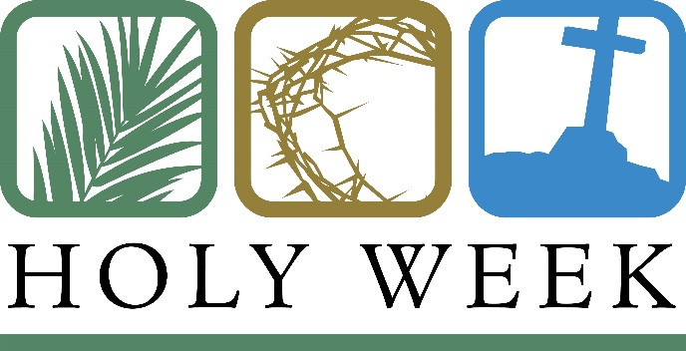

Opening

The opening songs are sung as the “symbol of our consent to God’s presence and action within.” They are an invitation to the Holy Spirit to move among us, filling us with God’s light and peace.

Silence

Gathering Song – Jesus Remember Me (1)
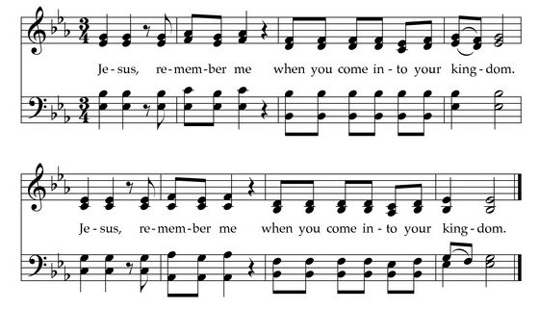

First Reading – Hebrews 13.20-21
Now the God of peace, that brought again from the dead our Lord Jesus, that great shepherd of the sheep, through the blood of the everlasting covenant, make you perfect in every good work to do his will, working in you that which is well-pleasing in his sight; through Jesus Christ, to whom be glory for ever and ever. Amen.

Silence

Song (8)
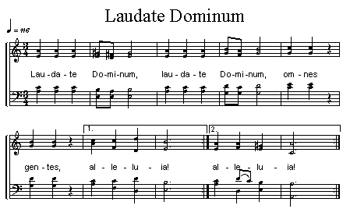

Silence

Psalm 139

¹ O Lord, you have searched me and known me. ² You know when I sit down and when I rise up; you discern my thoughts from far away.
³ You search out my path and my lying down, and are acquainted with all my ways. ⁴ Even before a word is on my tongue, O Lord, you know it completely. ⁵ You hem me in, behind and before, and lay your hand upon me. ⁶ Such knowledge is too wonderful for me; it is so high that I cannot attain it.

Glory be to the Father, and to the Son:
And to the Holy Ghost.
As it was in the beginning, is now, and ever shall be, world without end. Amen

Silence

Gospel Reading – Matthew 11.28-30
Come unto me, all ye that labour and are heavy laden, and I will give you rest. Take my yoke upon you, and learn of me; for I am meek and lowly in heart: and ye shall find rest unto your souls. For my yoke is easy, and my burden is light.

Silence

Song (7) – Lord Jesus Christ

Please light a candle during this song
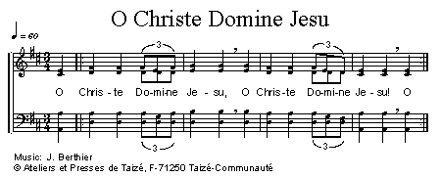

Prayers – We pray for our world, our church, our community and our families

Song (3) – O Lord hear my Prayer
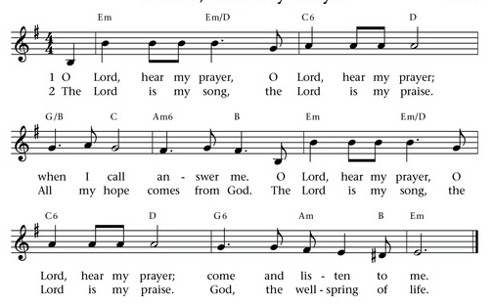

Silence
As our Saviour taught us, so we pray together

Our Father who art in heaven,
hallowed be thy name.
Thy kingdom come.
Thy will be done
on earth as it is in heaven.
Give us this day our daily bread,
and forgive us our trespasses,
as we forgive those who trespass against us,
and lead us not into temptation,
but deliver us from evil.
For thine is the kingdom,
the power, and the glory,
for ever and ever.
Amen.

Concluding Prayer

Jesus our peace, you never abandon us. And the Holy Spirit always opens a way forward, the way which consists in casting ourselves into God as into the depths. And astonishment arises: these depths are not an abyss of dark-ness; they are God—fathomless depths of compassion and innocence.

Amen

Concluding Song (11) – Praise the Lord, all you people
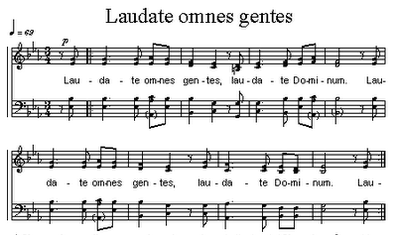

Silence

Dismissal
Loving God, we thank you for hearing our prayers,
feeding us with your word, and encouraging us in our meeting together.
Take us and use us to love and serve you, and all people,
in the power of your Spirit and in the name of your Son,
Jesus Christ our Lord. Amen.
Go in peace to love and serve the Lord. In the name of Christ Amen

Music will be played, please stay as long as you like or leave in silence.

